**CNN vs RNN: Which Neural Network Is Right for You?**

<https://missinglink.ai/guides/neural-network-concepts/cnn-vs-rnn-neural-network-right/>

A [Convolutional Neural Network (CNN)](https://missinglink.ai/guides/neural-network-concepts/using-convolutional-neural-networks-sentence-classification-2/) is a multi-layer neural network used to analyze images for image classification, segmentation or object detection. CNNs work by reducing an image to its key features and using the combined probabilities of the identified features appearing together to determine a classification. One advantage that CNNs have over other classification algorithms is that they require fewer hyperparameters and less supervision.

### **CNN**

CNNs are made up of three layer types—convolutional, pooling and fully-connected (FC).

In the convolutional layers, an input is analyzed by a set of filters that output a feature map. This output is then sent to a pooling layer, which reduces the size of the feature map. This helps reduce the processing time by condensing the map to it’s most essential information.

The convolutional and pooling processes are repeated several times, with the number of repeats depending on the network, after which the condensed feature map outputs are sent to a series of FC layers. These FC layers then flatten the maps together and compare the probabilities of each feature occurring in conjunction with the others, until the best classification is determined.

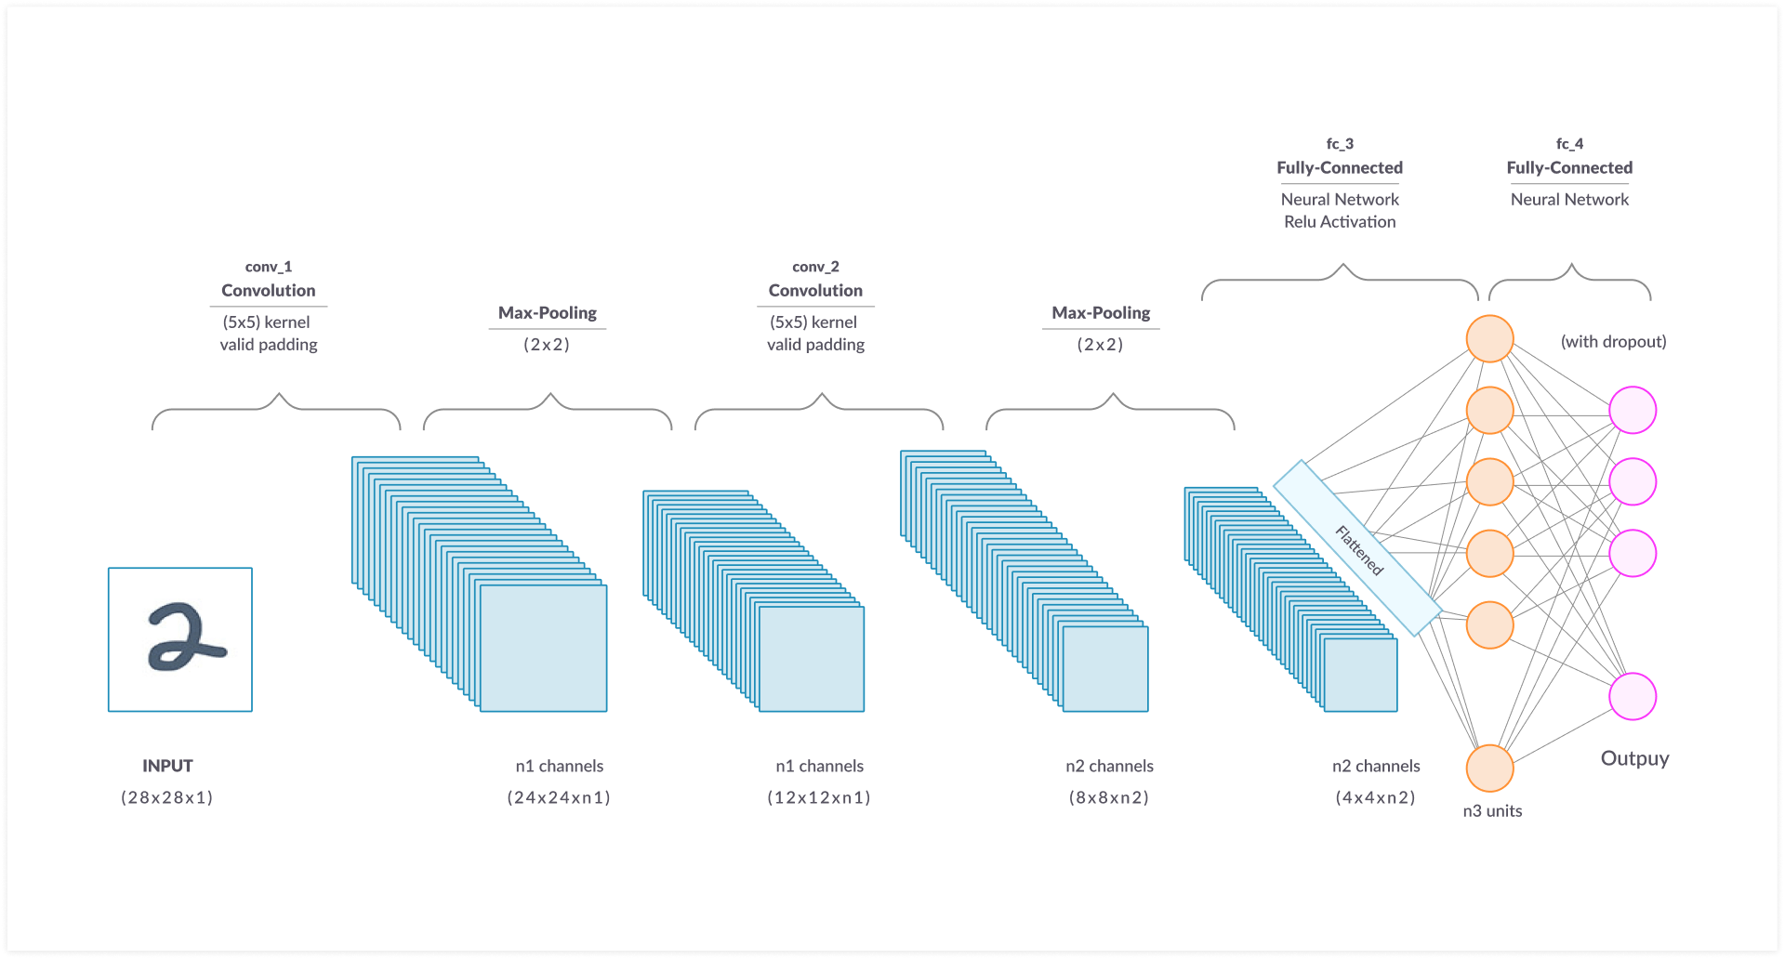

Illustration of CNN architecture layers

This architecture allows CNNs to learn the position and scale of features in a variety of images, making them especially good at the classification of hierarchical or spatial data and the extraction of unlabelled features. Unfortunately, this structure requires CNNs to only accept fixed-size inputs—and it only allows them to provide fixed-size outputs.

CNNs are currently being applied to several applications, including:

* **Computer vision**—medical image analysis, image recognition and face detection
* **Natural Language Processing (NLP)**—semantic parsing, sentence modeling and search query retrieval
* **Drug discovery**—the discovery of chemical features and prediction of medicinal benefits